How to make a simple switch: Teacher note
You can make a simple and inexpensive switch using some materials found in the classroom. Below are the instructions for two different switches and a picture of each one.
SWITCH ONE
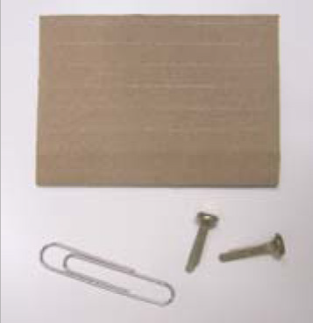
Materials:
- 8 cm x 4 cm thick cardboard (corrugated card)
- metal paper clip
- two split pins
Procedure:
- Place the thick cardboard down lengthways (landscape).
- Place the paper clip lengthways on the middle of the cardboard.
- Mark each end of the paper clip.
- Place one split pin through the cardboard at one end of the split pin.
- Push the other split pin through one end of the paper clip and attach to the cardboard.
- Check underneath the cardboard that the arms of the split pins are not touching.
- The wires of your circuit can be attached to the ‘arms’ of the split pins.
- Swing the paper clip so that it can connect with the split pin.
Open switch | Closed switch
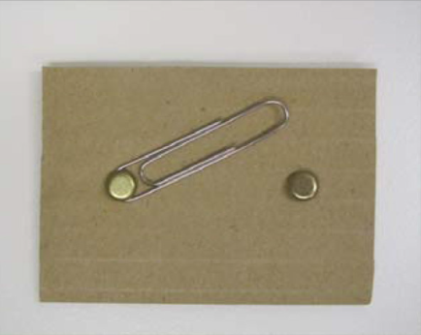 | 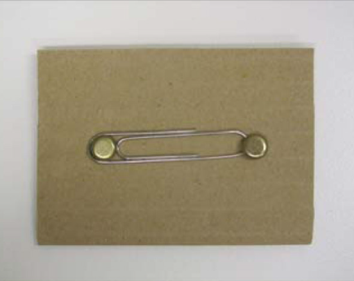
Completed switch with wires attached underneath to an arm of each split pin
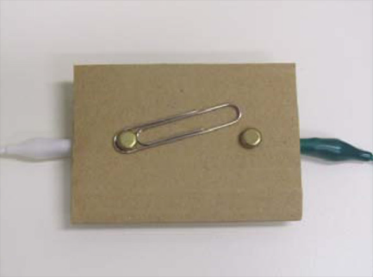 | 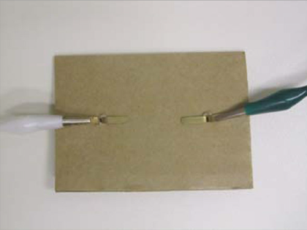

SWITCH TWO
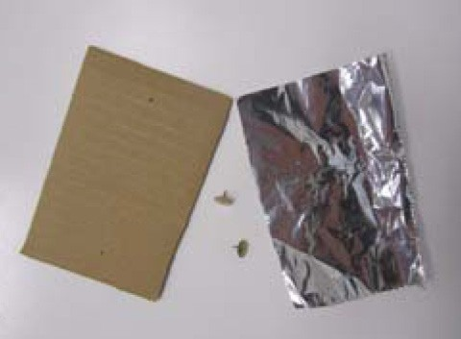
Materials:
- 8 cm x 4 cm thick cardboard (corrugated card)
- aluminium foil
- 2 x drawing pins
Procedure:
- Place the thick cardboard down lengthways (landscape).
- Fold a strip of aluminium foil lengthways to form a strip.
- Push one drawing pin through one end of the aluminium strip.
- Wrap the circuit wire around the shaft of the pin and push into the cardboard.
- Wrap a second circuit wire around the shaft of the second pin and push into the cardboard near the top of the aluminium strip.
- The aluminium strip can then be rotated in and out of contact with the second drawing pin to open and close the switch.
Open switch | Closed switch
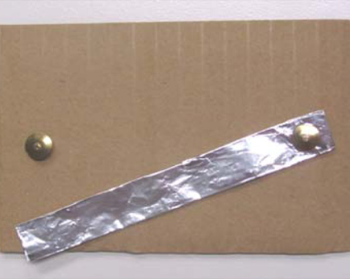 | 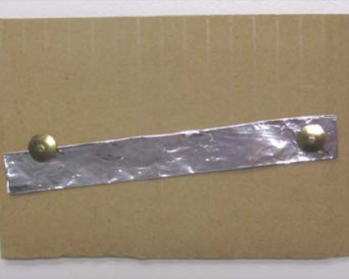
Completed switch with wires attached underneath to each thumb tack. | 